Red Zone
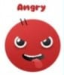

What is the Red Zone?
The red zone describes an extremely heightened state of intense emotions. When a person reaches the red zone, they’re no longer about to control their emotions or reactions.
This is the zone kids are in during meltdowns. Being in the red zone means you’re feeling anger, rage, terror, or complete devastation and feel out of control.

How would your child behave in the Red Zone?
- Excessive outbursts
- Fighting
- Shouting
- Irritability
- Acting dangerously
- Lack of control
- Resentful

What coping strategies do we implement in school?
- Take time out
- Use a stress ball
- Use the calm corner
- Time to talk through our thoughts, feelings and behaviours
- Breathing strategies

What strategies can you use at home?
- Talk to an adult
- Hug a teddy
- Pop bubble wrap
- Wrap your arms around yourself and squeeze
- Write down what’s bothering you and rip it up
- Squeeze a stress ball
- Talk about it
- Scribble on paper and crumple it up
- Use breathing techniques
- Do stretches
- Listen to calming music
- Take time out
- Use sensory glitter jars

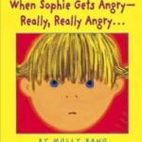
Stories to read at home
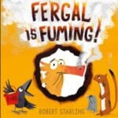
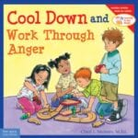

- Ravi’s Roar by Tom Percival | Read by Teacher Charla – YouTube

