Green Zone

What is the Green Zone?

The green zone is used to describe when you’re in a calm state of alertness. Being in the green zone means you are calm, focused, happy, or ready to learn. This is predominantly the state you want your child to be in. It’s also the state most needed in the classroom in order to learn.

How would your child behave in the Green Zone?
- Calm
- Focused
- Happy
- Content

What strategies do we implement in school to keep children in the Green Zone?
- Implement daily sensory breaks
- Sensory areas on the playground
- Celebrate Mental Health focused days throughout the school year
- PSHE lessons
- Mindfulness activities
- Circle time
- Use a positive behaviour policy
- Encourage a healthy lifestyle
- Teach children how to keep fit

What strategies can you use at home?
- Self-care- treat yourself to a relaxing bath or night off homework
- Organise your clothes for school the night before to prevent stress
- Spend time with your friends and family
- Take time out to do something you love to do
- Eat healthy and nutritious food
- Drink plenty of water
- Get 8 hours+ sleep

Stories to read at home
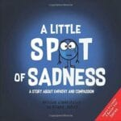
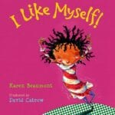

- Storytime for kids Augustus and his Smile by Catherine Rayner – Bing video
- The Jar of Happiness – YouTube
- Tough Guys (Have feelings too) – YouTube

